  - Objectives
Experiment (9)

Spanning Tree Protocol (STP)


To achieve importance of STP in Cisco Packet Tracker & eNSP

  - Equipment / Program Requirements:
Cisco Packet Tracker eNSP

  - Experiment Setup:
Open Simulator
Then make 3 Switches and do configurations to know Root Switch,non Root Switches , DP Ports ,and BW Ports in cable.

  - Simulation Results:

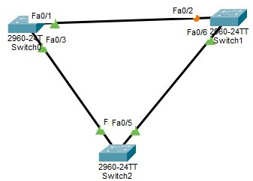
Cisco Packet Tracker:
Topology:

SW2 is root in the First Before I force SW1 become root switch:

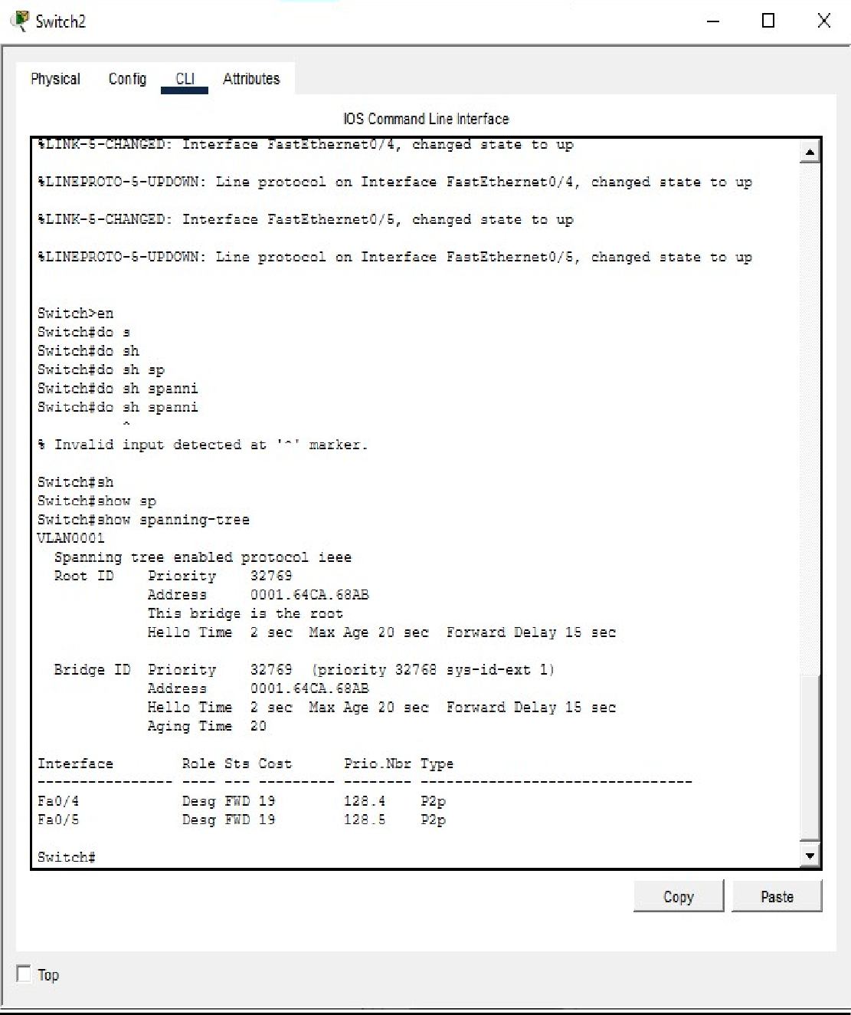

Sw1:

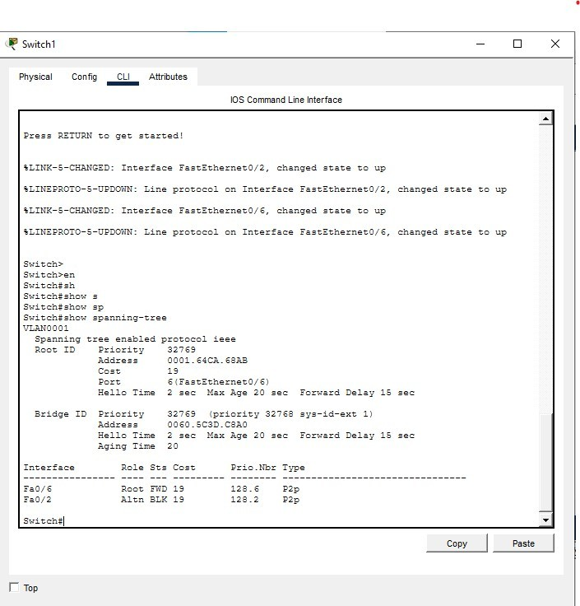

Sw 0:

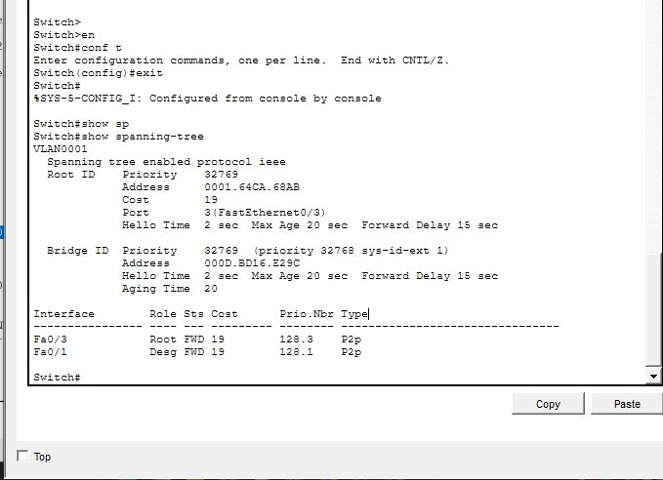

For sw1 make it root switch ( forced ):

Sw1(config)#spanning-tree vlan 1 priority 0 Then wait 50 second

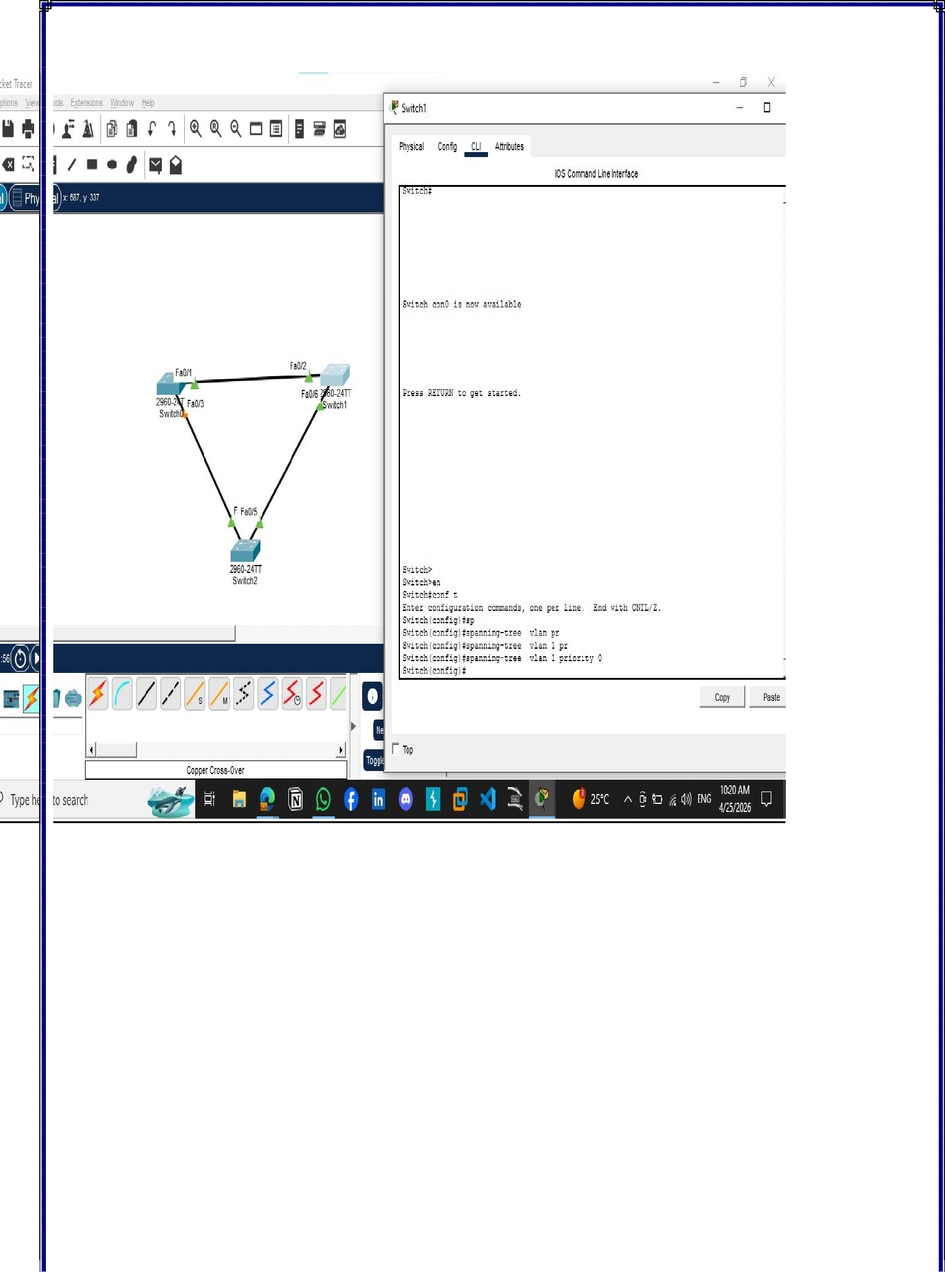

eNSP:
Topology:

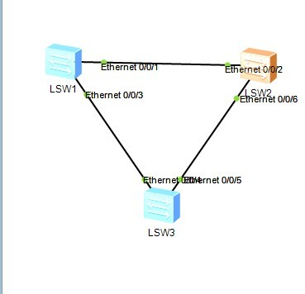

SW1:

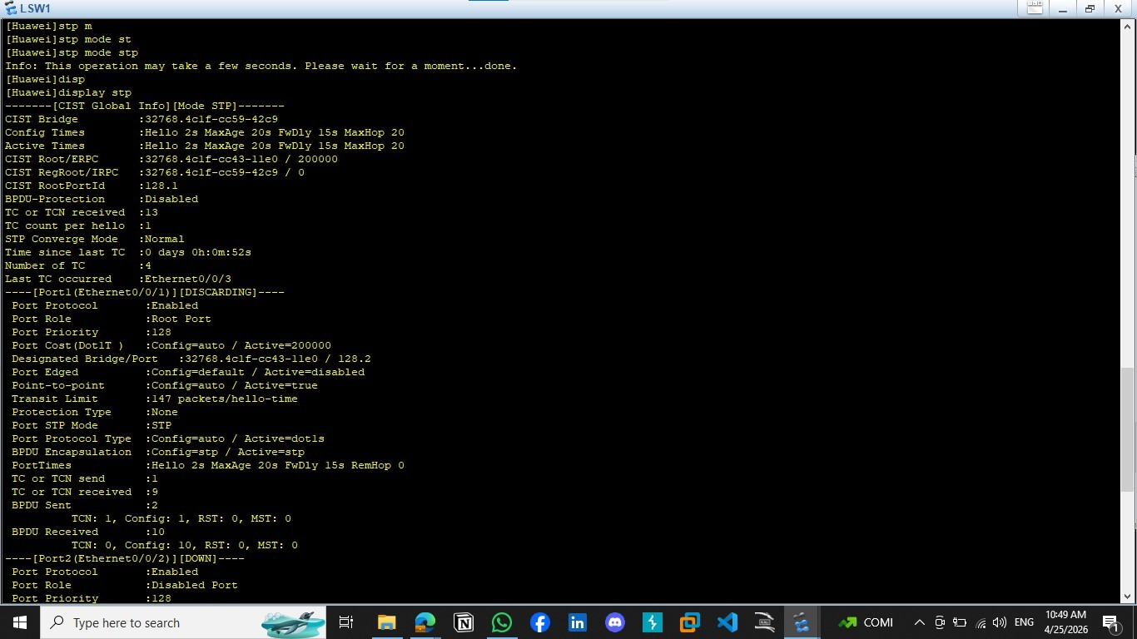

SW2:

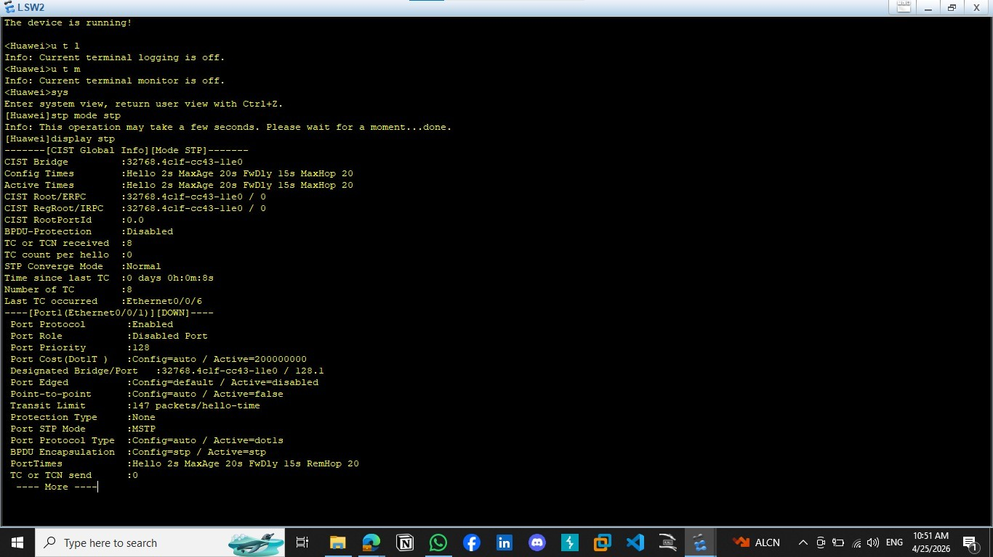

SW3:

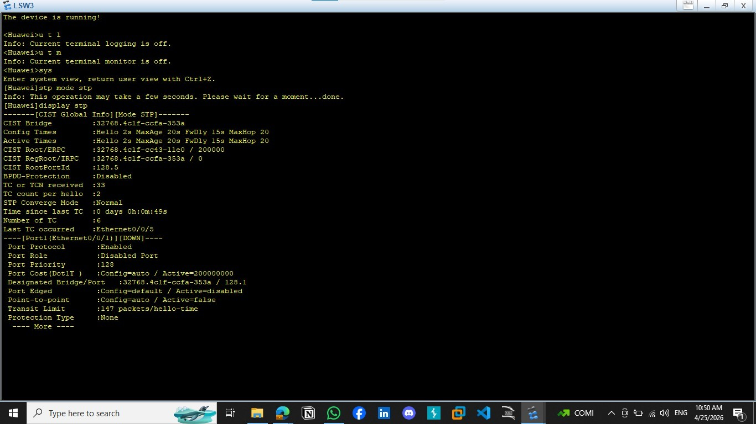

  - Conclusions:
Spanning Tree Protocol (STP) is essential in Layer 2 networks because it prevents switching loops that can cause broadcast storms, MAC table instability, and network failure.By creating a loop-free logical topology

